**Muhammad Tahir**

**K214503**

**Static Website Hosting**

1. **Bucket Name**: Provide the name and region of the bucket created.
2. 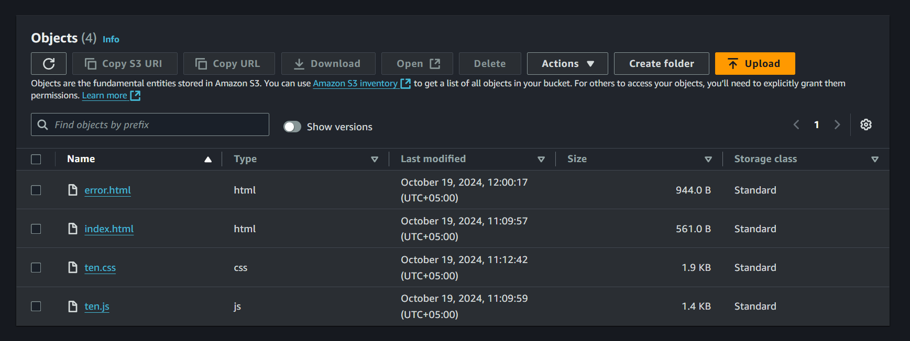

Name: tahir-aws-bucket1

Region: US East (N. Virginia) us-east-1

1. **Bucket Policy**: Submit a screenshot or JSON output of the bucket policy used for public access.

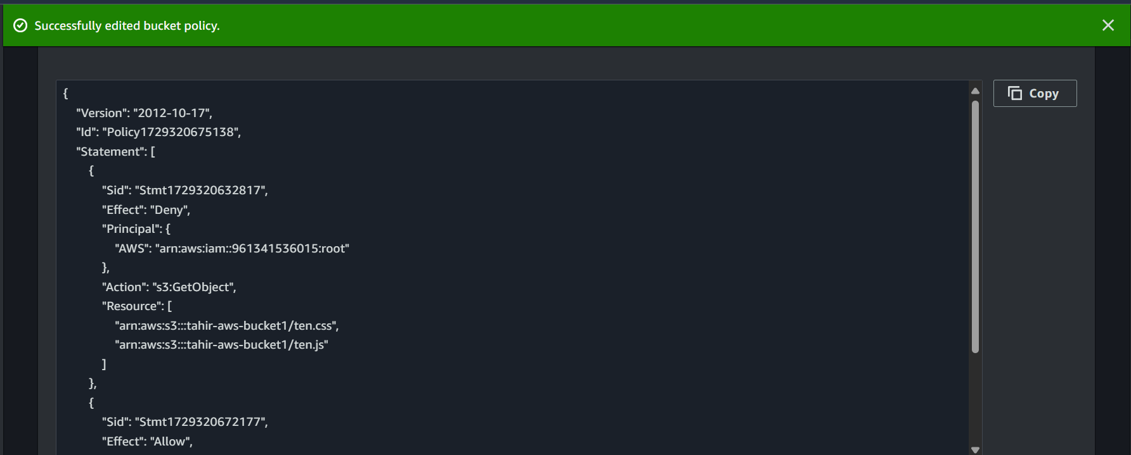

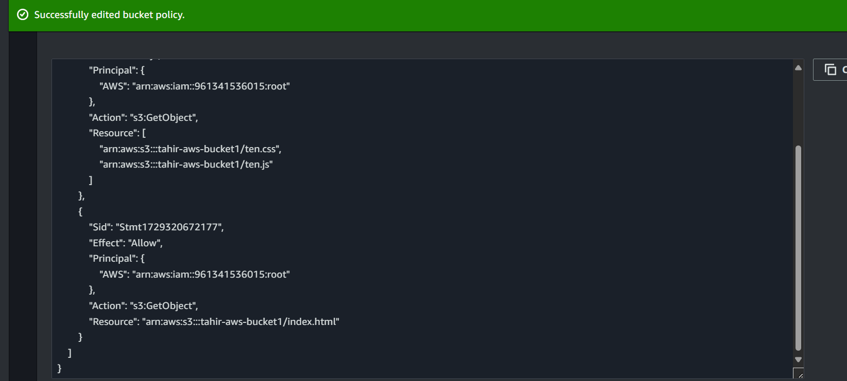

1. **Object URLs**: Provide the public URLs of at least two different objects (e.g., an HTML page and an image).

Index.html (https://tahir-aws-bucket1.s3.amazonaws.com/index.html)

Ten.css (https://tahir-aws-bucket1.s3.amazonaws.com/ten.css)

1. **Versioning**: Submit evidence (screenshot) that versioning is enabled, and show that an object version has been updated.

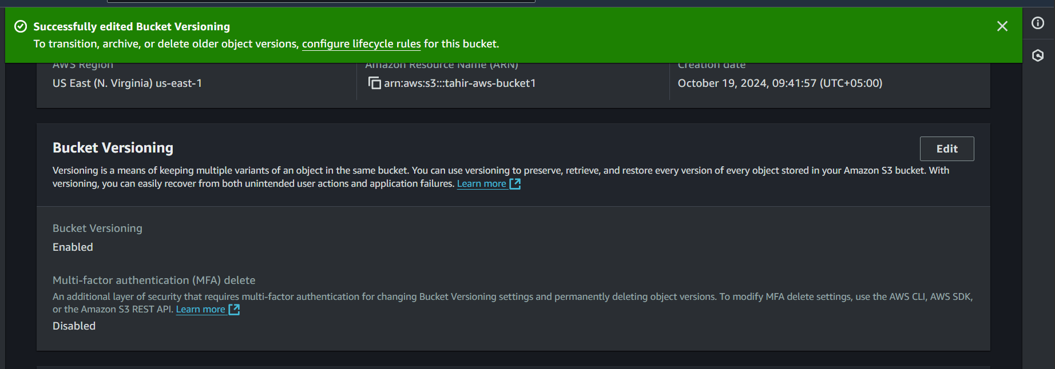

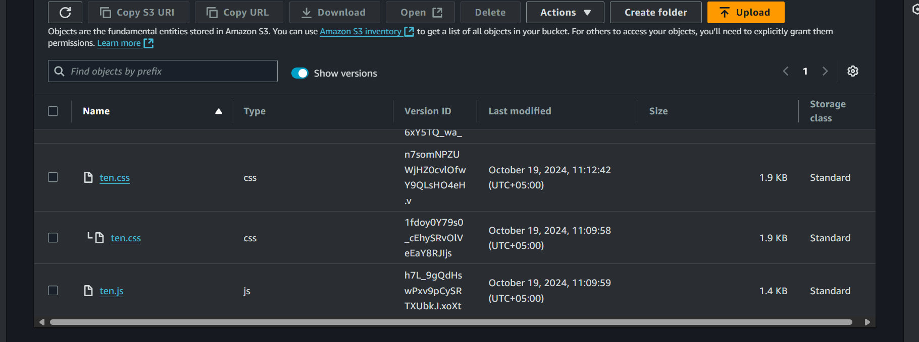

1. **Lifecycle Policy**: Submit a screenshot or configuration details of the lifecycle policy for transitioning objects to a different storage class.

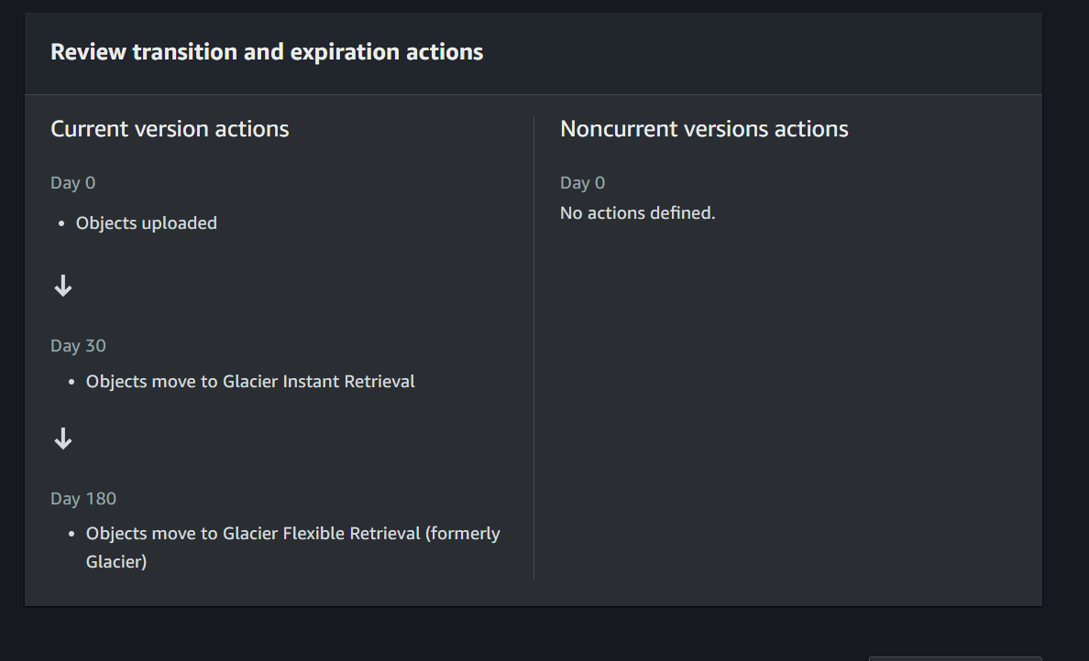

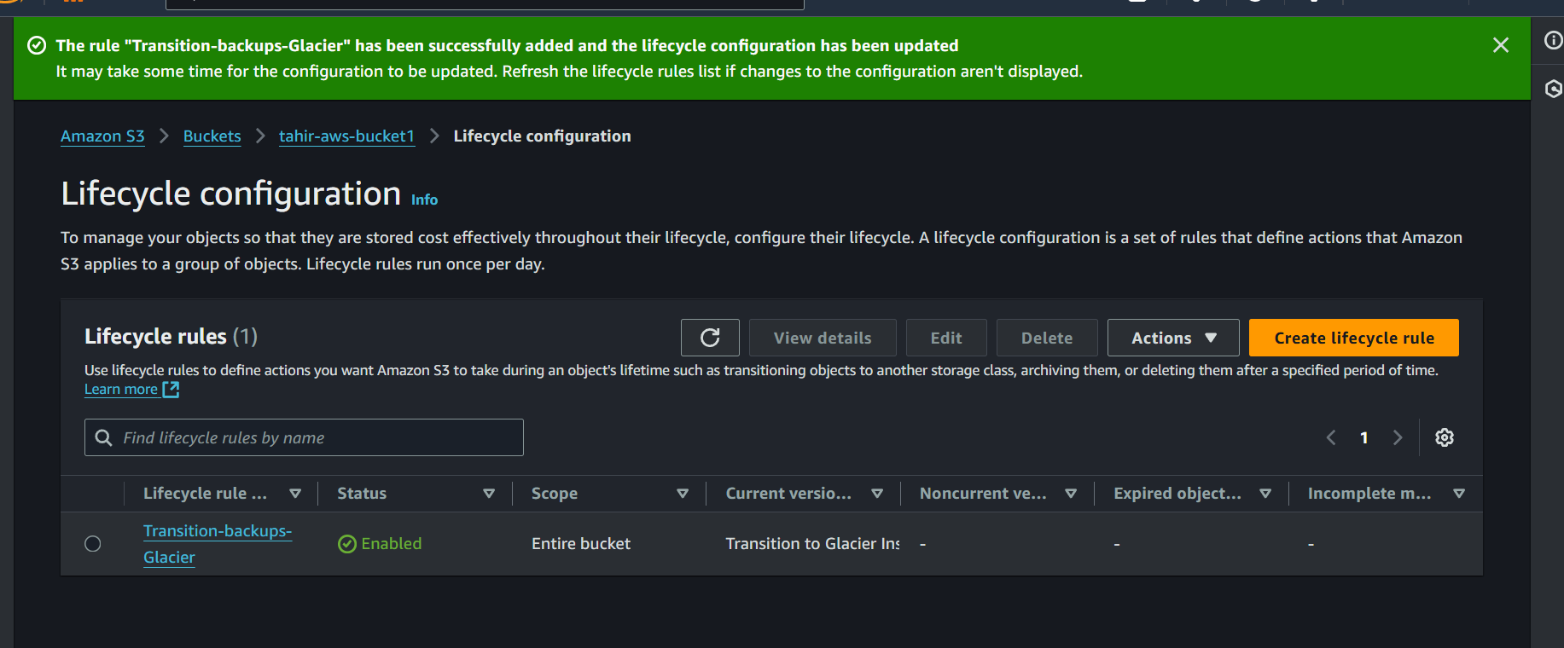

1. **Static Website URL**: Submit the public URL of the static website hosted on S3.

URL: http://tahir-aws-bucket1.s3-website-us-east-1.amazonaws.com